## horizontale lijn

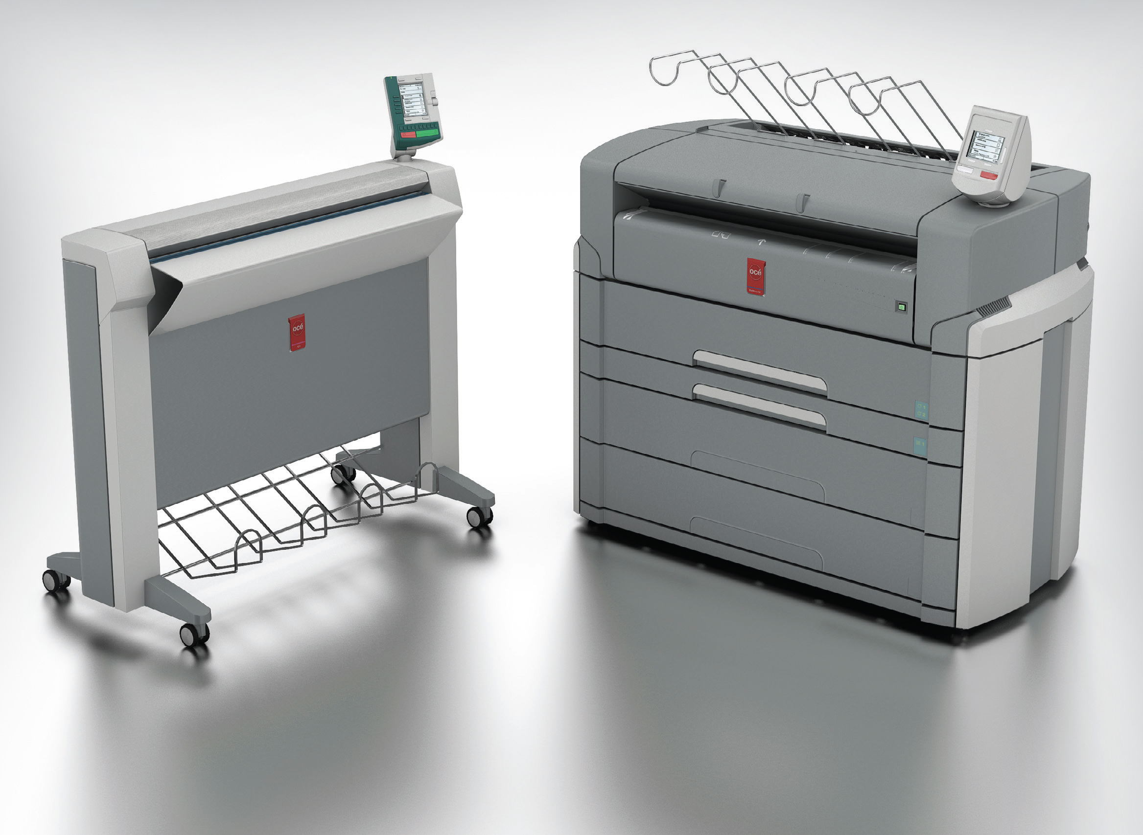

Océ printer research

14-6-2018

Anders and Bart

# 

# Overview

In this research we will examine some of the printers that Canon Oce sells. How much paper do they consume per hour? Is the printer using sheets or cut sheets? We need some answers to these questions to determine when the lights should start the fading. If the printer has a capacity of 10.000 sheets of paper, and it consumes approximately 2.500 per hour, we need to find out the specific percentage to signal the operator that it is time for a refill to prevent the printer to stop.

# Research Goal

To gain enough knowledge to determine at which percentage of capacity the light should start fading.

# Research Question

How much paper is consumed by Océ’s printers?

At what speed are the printers consuming paper?

## Voeg hier je tekst in

Voeg hier je tekst in Voeg hier je tekst in Voeg hier je tekst in Voeg hier je tekst in Voeg hier je tekst in Voeg hier je tekst in.

# Results

|  |  |  |  |
| --- | --- | --- | --- |
| Printer | Type | Paper (media) Capacity | Paper Consumption |
| Colorwave 700 | Rolls | Six rolls with a length of 200 meters. 1200 meters in total | 247 m² per hour |
| Arizona 6170 XTS | Boards: plywood, panel or other architectural applications | N/A | 33 boards per hour |
| VarioPrint i300 | Cut sheet | 9200 sheets | 9.120 |
| VarioPrint 6330 Titan series | Cut sheet | 16.000 sheets | 2000 books per day |
| Colorstream 6000 Chroma | Rolls:  70 mm, 3”, 5” and 6” |  | 125.000 personalized magazines per day  324-1714 A4/min |
| ProStream 1000 | Rolls:  3”, 5” and 6” |  | 1076 A4 per minute |
| Colorado 1640 | 64” roll-to-roll large format printer with UVgel technology | 50 kg per roll, 1 input roll, 1 output roll. | 159 m2/h |

To get useful information out of this data, we need to calculate the media consumption per hour. Than we can determine the total runtime, which is associated with the amount of refills needed.

|  |  |  |  |
| --- | --- | --- | --- |
| Printer | Media consumption per hour | Total runtime on full media load | Explanation |
| Colorwave 700 | 247 m² | Approximately 5 hour |  |
| Arizona 6170 XTS | 33 boards | N/A (no paper tray) |  |
| VarioPrint i300 | 9.120 | Approximately 1 hour |  |
| VarioPrint 6330 Titan series | 19.680 | Approximately 50 minutes | Assuming the paper is A4. |
| Colorstream 6000 Chroma | No information | No information |  |
| ProStream 1000 | 4.800 meters | No information |  |
| Colorado 1640 | 159 m2 | Approximately 1 hour 50 minutes | assuming 170 gram/m2 paper is used. |

We use three machines in our demo application. It will be implemented as followed:

Colorwave 700

Fade start time: 20 minutes before runout. 4%

Red light: 10 minutes before runout. 2%

Flashing: 5 minutes before runout. 1%

VarioPrint i300

Fade start time: 20 minutes before runout. 33%

Red light: 10 minutes before runout. 16%

Flashing: 5 minutes before runout. 8%

Colorado 1640

Fade start time: 20 minutes before runout. 18%

Red light: 10 minutes before runout. 9%

Flashing: 5 minutes before runout. 5%

# Conclusion

The printers have different specifications meaning, that they do not have the same capacity and print speed. We have found some numbers and made some few assumptions eg. how much time it takes to refill the paper tray. The lights will not start fading at a static value.

# Recommendation

To make the simulation in the app more realistic, we base the variable degrading on the found numbers in the research. With the knowledge we have gained from the research, we have decided, that the best solution would be to give the operator enough time to refill the paper. Our equations is based on that the lights should start fading when there is paper enough for 20 minutes. That means that each printer has a specific and individual percentage value where the light will start fading.

# SOURCES

Printer: Colorwave 700

Sites:

<https://www.canon.co.uk/for_work/products/large_format_printers/technicalprint/colour/oce_colorwave_700/>

Videos:

<https://www.youtube.com/watch?v=_TshULmcdGk&t=125s>

Printer: Arizona 6170 XTS

Sites:

Videos:

<https://www.youtube.com/watch?v=6sEJfqrdbjg>

<https://www.youtube.com/watch?v=SCi8Ze5Cj9I&t=83s>

Printer: VarioPrint i300

Sites:

<https://www.canon-europe.com/business-printers-and-faxes/cut-sheet-colour-printers/varioprint-i300/specifications/>

Videos:

<https://www.youtube.com/watch?v=g2xa9ksY3N4>

Printer: VarioPrint 6330 Titan

Sites:

<https://www.canon.com.cy/business-printers-and-faxes/cut-sheet-black-and-white-printers/varioprint-6330-titan/specifications/>

Videos:

Printer: Colorstream 6000 Chroma

Sites:

<https://www.canon.co.uk/for_work/products/professional_print/digital_colour_production/colorstream_6000_chroma/specification.aspx>

Videos:

<https://www.youtube.com/watch?v=Gbn2dk15ImE>

Printer: ProStream 1000

Sites:

<https://csa.canon.com/online/portal/csa/csa/company/campaigns/oce-prostream-series>

Videos:

<https://www.youtube.com/watch?v=DObf3wxLzJ0>

Printer: Colorado 1640

Sites:

<https://www.canon-europe.com/business-printers-and-faxes/oce-colorado-1640/specifications/>

Videos: